**1. Overview of the backend**

The backhand of this project is divided mainly into four parts and they are solved by following a sequential pattern. First, they are stated in brief, and then each part is discussed in detail. Here is a list of different Functionality of the backhand of the project.

1. Location
2. Data Set
3. AR (Augmented Reality) Camera
4. Water level

Tools and Applications Used

1. Unity
2. Unity asset store
3. Visual Studio

Programming Language

1. C sharp

**1.1 Unity**

The most popular use of the Unity engine is in the creation of games and other applications that call for animated effects. Since then, the engine has gradually expanded. The application is a user-friendly tool that even supports experienced learners.



*Fig1. Unity logo*

The above image shows the logo of the project development engine known as Unity.

This can be downloaded from the official site of Unity and can be installed both for windows as well as for macOS. The given link can be used for downloading.

<https://unity3d.com/get-unity/download>

**1.2 Unity Asset store**

Unity asset stores in an online website that stores the different assets and prefabs that are used in Unity for application development. It includes a variety of different animation tools that can be purchased and can be utilized depending on the demand of the developer. This project focuses on the water animation which is downloaded from the Unity asset store and imported into the Unity assets.



*Fig1.2 Unity asset store logo*

The following link can be used for downloading/purchasing the different assets from the Unity asset store.<https://assetstore.unity.com/>

1.3 Visual Studio

An Integrated Development Environment is Microsoft's Visual Studio (IDE). The development of computer programs, websites, web apps, web services, and mobile applications all use it.



*Fig.1.3 Logo visual studio*

1. **Location**

As discussed earlier location and altitude is the major part of the project that helps to locate the user's device and also opens the gate for the further functionality of the application.

1. To achieve this goal a component is created in Unity by the name of “Code” and a C sharp script is inserted in that component.
2. Csharp empty script can be created in unity by clicking the create C# Script option.
3. The provided Csharp code at the end is written in that empty script with the help of visual studio.
4. After compilation, the Code component will provide two options.
5. Text asset data

This area is space for inserting the relevant data of the script on which the code is working

1. Output Area

This area is for the displaying of the text after the compilation which can be further modified by UI/UX.

5. Then the CSV file of the data set is inserted in the Text asset data.

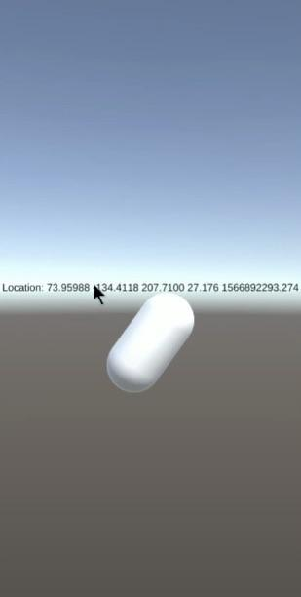

*fig.2.1 Game object*

The above image shows all the components and things that are discussed in the above steps under the Location and the second image shows the coordinates along with the altitude of the location.

Here is the corresponding source code that is used for figuring out the location coordinates as well as the altitude of the particular location.

**Code:**

using System.Collections;

using System.Collections.Generic;

using UnityEngine;

using System;

using UnityEngine.UI;

using UnityEngine.Android;

public class Display_data : MonoBehaviour

{

public static int water level = 20;

public Text outputArea;

public Text gpsOut;

int tableSize;

public bool isUpdating;

public TextAsset textAssetData;

public static int getWaterLevel()

{

return waterLevel;

}

public class player

{

public string pointid;

public float grid_code_1;

public float X;

public float Y;

public float grid_code_5;

}

[System.Serializable]

public class PlayerList

{

public player[] player;

}

public PlayerList myPlayerList = new PlayerList();

public string compareData(string lat, string lon, float alt)

{

int precise, precise2;

if (lat.Substring(0, 1) == "-")

{

precise = 6;

}

else if (lat.Substring(0, 1) == "0")

{

precise = 1;

}

else

{

precise = 5;

}

if (lon.Substring(0, 1) == "-")

{

precise2 = 6;

}

else if (lon.Substring(0, 1) == "0")

{

precise2 = 1;

}

else

{

precise2 = 5;

}

for (int i = 0; i < tableSize; i++)

{

string datalat = myPlayerList.player[i].Y.ToString();

string datalon = myPlayerList.player[i].X.ToString();

if (string.Equals(datalat, lat.Substring(0, precise)) && string.Equals(datalon, lon.Substring(0, precise2)))

{

int conv1 = watersc.conv1;

string level = "";

if (conv1 == 1)

{

level = "Water Level : " + myPlayerList.player[i].grid_code_1.ToString();

if (alt < 40)

{

waterLevel = (int)myPlayerList.player[i].grid_code_1;

}

else

{

waterLevel = -10;

}

}

else

{

level = "Water Level : " + myPlayerList.player[i].grid_code_5.ToString();

if (alt < 40)

{

waterLevel = (int)myPlayerList.player[i].grid_code_5;

}

else

{

waterLevel = -10;

}

}

return level.Substring(0, 19);

}

}

return "Water Level : 0 ";

}

void Start()

{

ReadCSV();

}

void ReadCSV()

{

string[] data = textAssetData.text.Split(new string[] { ",", "\n" }, StringSplitOptions.None);

tableSize = data.Length / 5 - 1;

string myString = Convert.ToString(tableSize);

myPlayerList.player = new player[tableSize];

for (int i = 0; i < tableSize; i++)

{

myPlayerList.player[i] = new player();

myPlayerList.player[i].pointid = (data[5 * (i + 1)]);

myPlayerList.player[i].grid_code_1 = float.Parse(data[5 * (i + 1) + 1]);

myPlayerList.player[i].X = float.Parse(data[5 * (i + 1) + 2]);

myPlayerList.player[i].Y = float.Parse(data[5 * (i + 1) + 3]);

myPlayerList.player[i].grid_code_5 = float.Parse(data[5 * (i + 1) + 4]);

}

}

private void Update()

{

if (!isUpdating)

{

StartCoroutine(GetLocation());

isUpdating = !isUpdating;

}

}

IEnumerator GetLocation()

{

if (!Permission.HasUserAuthorizedPermission(Permission.FineLocation))

{

Permission.RequestUserPermission(Permission.FineLocation);

Permission.RequestUserPermission(Permission.CoarseLocation);

}

// First, check if user has location service enabled

if (!Input.location.isEnabledByUser)

yield return new WaitForSeconds(10);

// Start service before querying location

Input.location.Start();

// Wait until service initializes

int maxWait = 10;

while (Input.location.status == LocationServiceStatus.Initializing && maxWait > 0)

{

yield return new WaitForSeconds(1);

maxWait--;

}

// Service didn't initialize in 20 seconds

if (maxWait < 1)

{

outputArea.text = "Timed out";

print("Timed out");

yield break;

}

// Connection has failed

if (Input.location.status == LocationServiceStatus.Failed)

{

outputArea.text = "Unable to determine device location";

print("Unable to determine device location");

yield break;

}

else

{

outputArea.text = compareData(Input.location.lastData.latitude.ToString(), Input.location.lastData.longitude.ToString(), Input.location.lastData.altitude);

gpsOut.text = "Location: " + Input.location.lastData.latitude + " " + Input.location.lastData.longitude + " " + Input.location.lastData.altitude;

}

// Stop service if there is no need to query location updates continuously

isUpdating = !isUpdating;

Input.location.Stop();

}

}

**1.4 Data Set**

The next important step for building up this project includes the data set that is used in the form of a CSV file.

CSV File.

This file includes the list of the different Coordinates from the different regions along with their increased future water level. This can be shown by the sample data set in the following image.

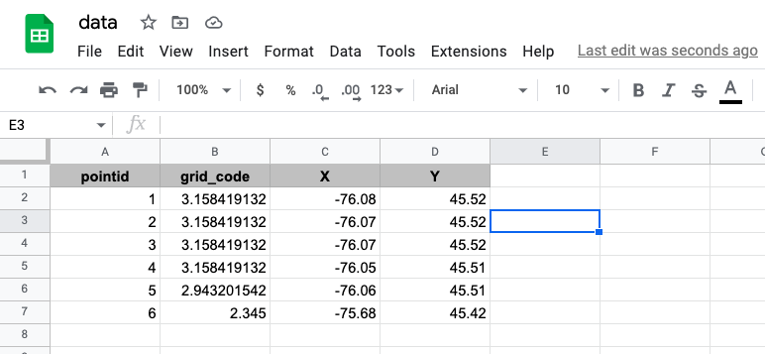

*Fig1.4 csv database for location and water level*

This CSV file is created by using ArcGIS software which is explained in more detail when the extraction of the data set is discussed.

Steps for inserting the CSV.

1. The file is created in CSV format and it can be easily imported into unity assets.
2. Then this CSV file is dragged and dropped in the “Text Asset Data” option in the “Code” component.
3. The same source code is modified to read the CSV file as well as compare the live coordinates with the pre-written coordinates in the CSV file.
4. After comparing it the code finds the current location coordinate in the file and displays the predicted water level attached to it.

This is how the location coordinates are taken and matched and the water level is displayed on the screen that gives the user the theoretical information about the sea level rise in their particular area. Here is the code that reads the CSV file as well as compares it with the live Coordinates.

**source Code:**

using System.Collections;

using System.Collections.Generic;

using UnityEngine;

using System;

using UnityEngine.UI;

using UnityEngine.Android;

public class Display_data : MonoBehaviour

{

public static int waterLevel = 0;

public Text outputArea;

public Text gpsOut;

int tableSize;

public bool isUpdating;

public TextAsset textAssetData;

[System.Serializable]

public static int getWaterLevel()

{

return waterLevel;

}

public class player

{

public int pointid;

public float grid_code;

public float X;

public float Y;

}

[System.Serializable]

public class PlayerList

{

public player[] player;

}

public PlayerList myPlayerList = new PlayerList();

public string compareData(string lat, string lon,float alt)

{

int precise, precise2;

if (lat.Substring(0, 1) == "-")

{

precise = 6;

}

else if (lat.Substring(0, 1) == "0")

{

precise = 1;

}

else

{

precise = 5;

}

if (lon.Substring(0, 1) == "-")

{

precise2 = 6;

}

else if (lon.Substring(0, 1) == "0")

{

precise2 = 1;

}

else

{

precise2 = 5;

}

for (int i = 0; i < tableSize; i++)

{

string datalat = myPlayerList.player[i].Y.ToString();

string datalon = myPlayerList.player[i].X.ToString();

if (string.Equals(datalat, lat.Substring(0, precise)) && string.Equals(datalon, lon.Substring(0, precise2)))

{

string level = "Water Level : " + myPlayerList.player[i].grid_code.ToString();

if (alt<30)

{

waterLevel = (int)myPlayerList.player[i].grid_code;

}

else

{

waterLevel = -10;

}

return level.Substring(0, 19);

}

}

return "DATA NOT FOUND";

}

void Start()

{

ReadCSV();

}

void ReadCSV()

{

string[] data = textAssetData.text.Split(new string[] { ",", "\n" }, StringSplitOptions.None);

tableSize = data.Length / 4 - 1;

string myString = Convert.ToString(tableSize);

myPlayerList.player = new player[tableSize];

//outputArea.text = loc.ToString();

for (int i = 0; i < tableSize; i++)

{

myPlayerList.player[i] = new player();

myPlayerList.player[i].pointid = int.Parse(data[4 * (i + 1)]);

myPlayerList.player[i].grid_code = float.Parse(data[4 * (i + 1) + 1]);

myPlayerList.player[i].X = float.Parse(data[4 * (i + 1) + 2]);

myPlayerList.player[i].Y = float.Parse(data[4 * (i + 1) + 3]);

}

}

private void Update()

{

if (!isUpdating)

{

StartCoroutine(GetLocation());

isUpdating = !isUpdating;

}

}

IEnumerator GetLocation()

{

if (!Permission.HasUserAuthorizedPermission(Permission.FineLocation))

{

Permission.RequestUserPermission(Permission.FineLocation);

Permission.RequestUserPermission(Permission.CoarseLocation);

}

// First, check if user has location service enabled

if (!Input.location.isEnabledByUser)

yield return new WaitForSeconds(10);

// Start service before querying location

Input.location.Start();

// Wait until service initializes

int maxWait = 10;

while (Input.location.status == LocationServiceStatus.Initializing && maxWait > 0)

{

yield return new WaitForSeconds(1);

maxWait--;

}

// Service didn't initialize in 20 seconds

if (maxWait < 1)

{

outputArea.text = "Timed out";

print("Timed out");

yield break;

}

// Connection has failed

if (Input.location.status == LocationServiceStatus.Failed)

{

outputArea.text = "Unable to determine device location";

print("Unable to determine device location");

yield break;

}

else

{

outputArea.text = compareData(Input.location.lastData.latitude.ToString(), Input.location.lastData.longitude.ToString(), Input.location.lastData.altitude);

gpsOut.text = "Location: " + Input.location.lastData.latitude + " " + Input.location.lastData.longitude + " " + Input.location.lastData.altitude;

Input.location.lastData.longitude + " " + Input.location.lastData.altitude + 100f + " " + Input.location.lastData.horizontalAccuracy + " " + Input.location.lastData.timestamp;

Input.location.lastData.longitude + " " + Input.location.lastData.altitude + " " + Input.location.lastData.horizontalAccuracy + " " + Input.location.lastData.timestamp);

}

Input.location.lastData.longitude.ToString(), + " " + Input.location.lastData.altitude.ToString(), + " " + Input.location.lastData.horizontalAccuracy.ToString(), + " " + Input.location.lastData.timestamp.ToString());

// Stop service if there is no need to query location updates continuously

isUpdating = !isUpdating;

Input.location.Stop();

}

}

**2.2. Unity Camera**

**2.2.1. Main camera**

This camera includes the representation of different objects according to the created animated Scene. This camera is mainly used for testifying to the object's position and its presence on the Screen compared to its dimensions.

**2.2.2 AR camera**

This camera is used for the real-time visuals of a particular place by using augmented reality As the project focuses on the live camera visuals for the animation so the AR camera is used here In a place of the main camera.

Here we proceed to the second scene of the backhand which includes the AR Camera. The development of this scene includes an animated version of water.

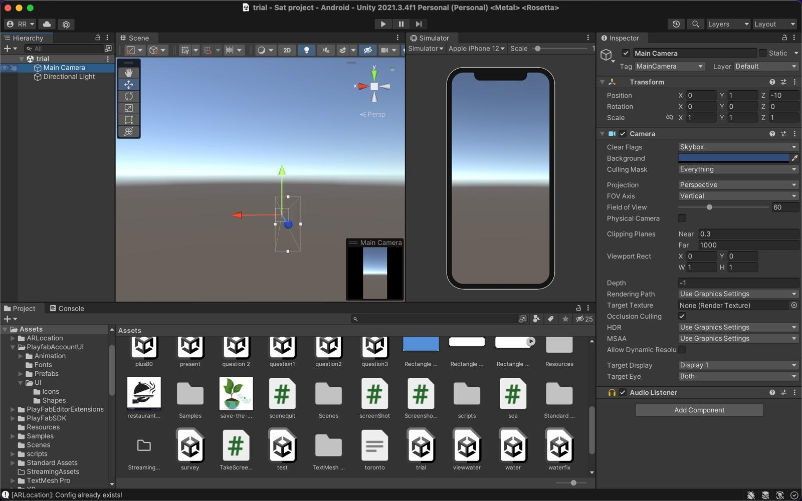 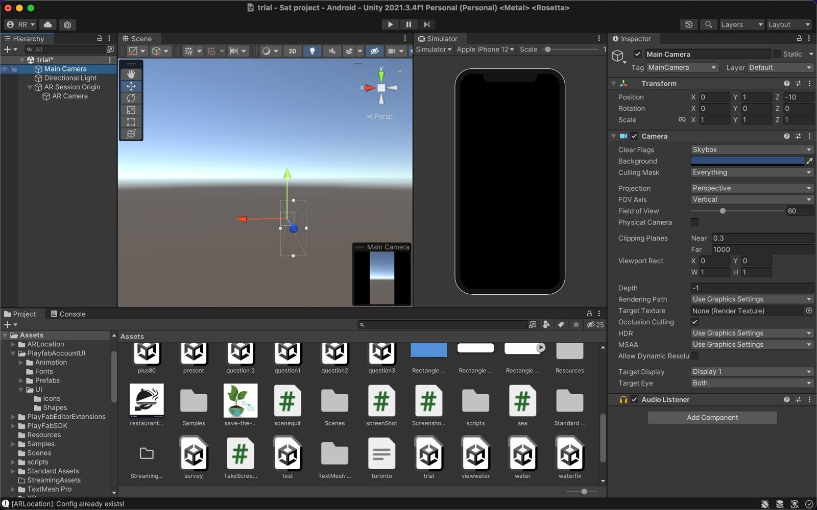

*Fig.2.1. Main camera framing fig2.2. AR camera framing*

The above fig.2.1 shows the Unity screen that includes the main camera and the fig.2.2 shows the introduction of the AR camera that can be recognized by the black screen in the Simulator. The main camera is deleted and the AR camera is used as the primary camera for the visual representation of the water level.

**2.3. Water Level.**

The water animation is used by importing a package named “Standard Package” that includes the different water animation prefabs and the one used here is “Water4 Advanced”.

Steps to get Water prefab

1. Open the Unity Asset store and import “Standard Package” Under “Standard Package” download the “Environment” prefab which holds the” Water Advance” prefab, and extract and import that prefab to unity assets.

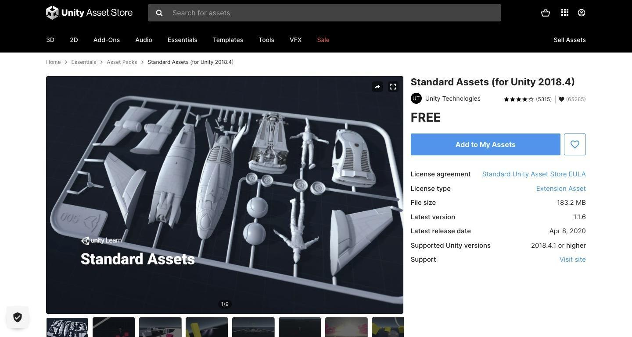

*Fig.2.3.1 Standard asset*

The fig.2.3.1 shows the “Standard assets” in the Unity asset store.

1. Create another container named “Water Component” in which the prefab can be stored just by drag and drop.
2. Drag the “Water Component” to the screen in the AR Camera and adjust both the AR camera as well as a container to make it accurate and adjust the alignment accordingly.

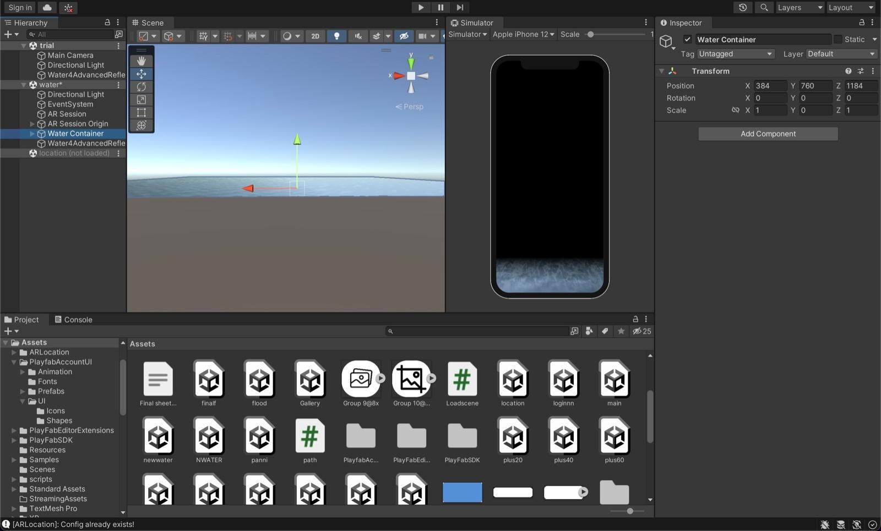

*Fig.2.3.2 Create water container*

Fig. 2.3.2 shows the presence of water prefab on the Simulator screen which confirms the presence of water on the AR camera.

**2.3.4 Water adjustment**

We have inserted the script in the container “ Water Component” to accommodate the water level on the screen based on the location coordinates and water level displayed on the screen. This code helps in taking the water level from another script and merging it with the water prefab and adjusting it accordingly.

**Source code**

using System.Collections;

using System.Collections.Generic;

using System.Numerics;

using UnityEngine;

using UnityEngine.UI;

public class sea: MonoBehaviour

{

public int level = Display_data.getWaterLevel();

void Start()

{

transform.position = new Vector3(0, Display_data.getWaterLevel(), 0);

}

void Update()

{

transform.position = new Vector3(0, Display_data.getWaterLevel(), 0);

}

}

**2.3.4.1 Water level display on AR camera.**

the above source code the positioning of the water level can be changed. Here we have images of the depicted water level and its corresponding changes. It reflects how the water level changes through the AR camera with different sea level rising in different areas or different coordinates.

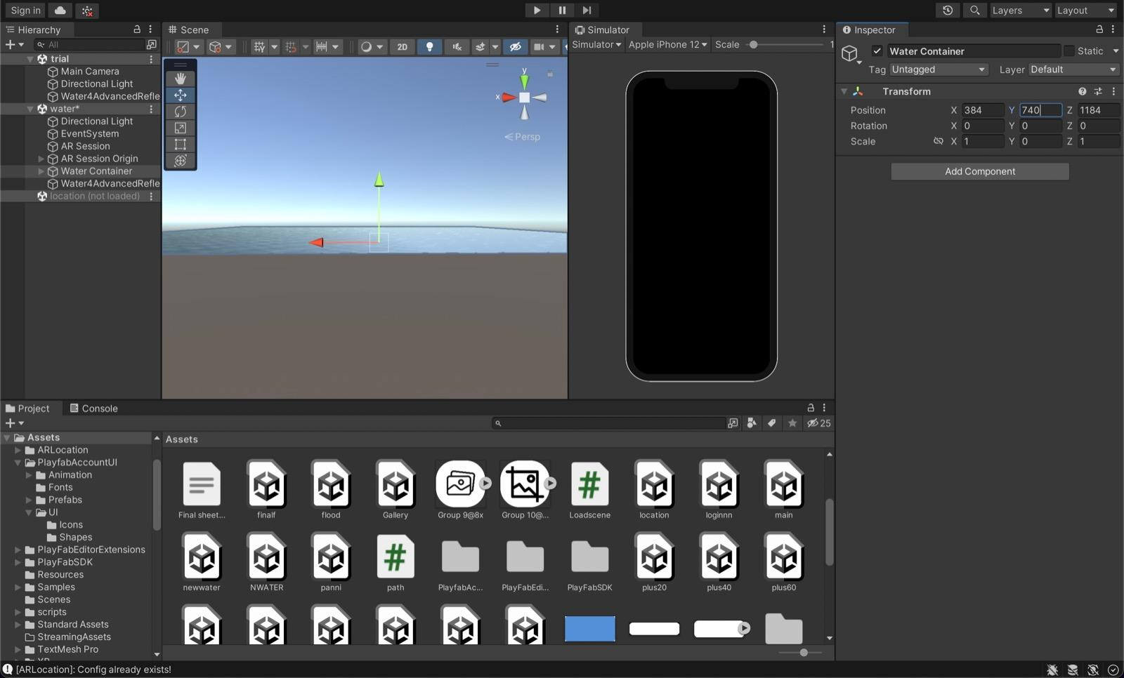

*Fig2.3.4.1 No water level representation on stimulator*

Fig 2.3.4.2 depicts the “0” water level or no water level as it can be represented with no water effect on the right Simulator screen.

Here some of the Water effects can be visualized at the bottom part of the Simulator Screen which shows some meters of rise in the Water level of the particular area.

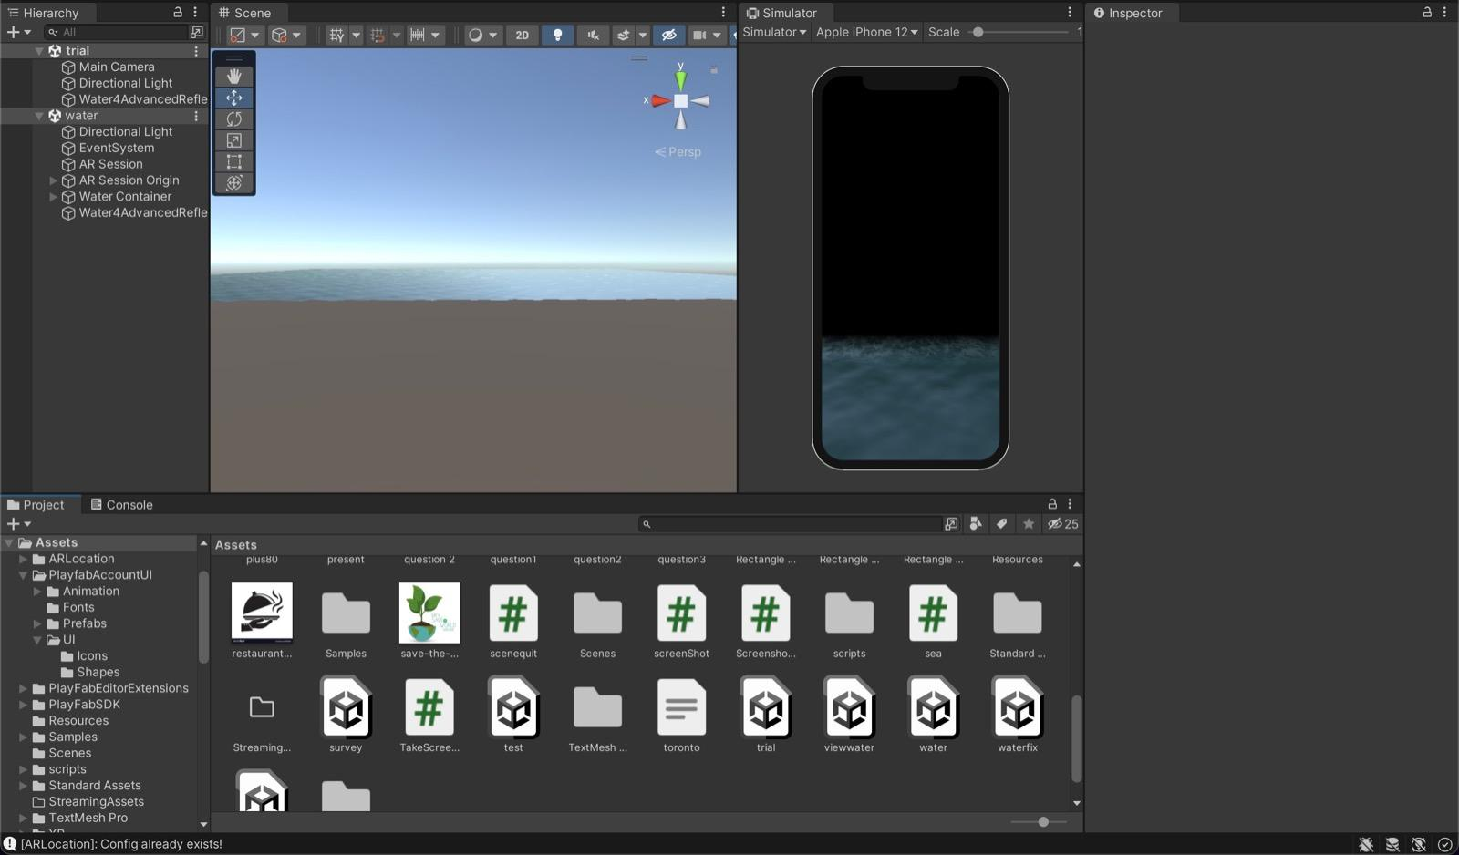

*Fig2.3.4 Water stimulation*

**2.4 Backend Conclusion**

Finally, we can able to extract the location of the user with help of their device Coordinates and then compared them with our data set and depict the water level of that location in the next scene, we created an AR camera in unity and project a water animation on that which works based on the water level of that particular location.

**3. UI/UX Design and Development**

**3.1 Recurring Function**

UI/UX without any flow and control is like a 2D art piece, there are many Recurring functions that have been defined ahead of time which helps the developer make use of them when needed.

1. Load Scene
2. Screen Capture
3. Gallery
4. Quit
5. Hashtag
6. Video learning

These are the most recurring functions that have been called multiple times in the duration of the project.

**3.1.1 Load Scene**

As the name, suggest a simple function that would switch to another scene upon activation.

Unity application development majorly implements scene switches to transition from one slide to another.

**Code :**

using System.Collections;

using System.Collections.Generic;

using UnityEngine;

using UnityEngine.SceneManagement;

public class Loadscene : MonoBehaviour

{

[SerializeField]

string sceneName;

public void Load()

{

SceneManager.LoadScene(sceneName); //( Important line)

}

}

The transition from one scene to another Example: switch from scene one to another by adding the Load scene function to a Button UI in Unity.

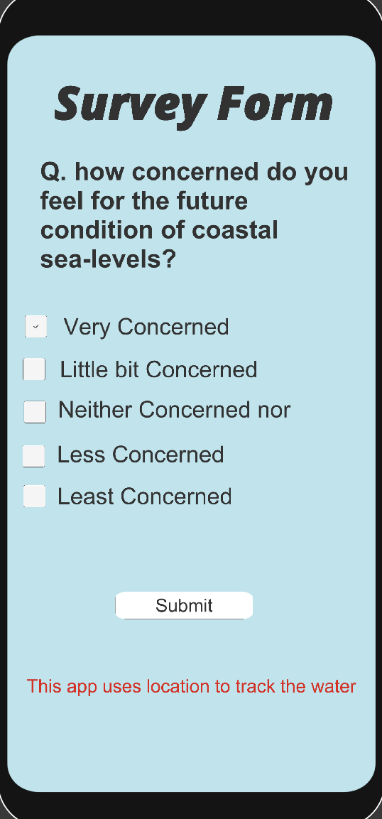 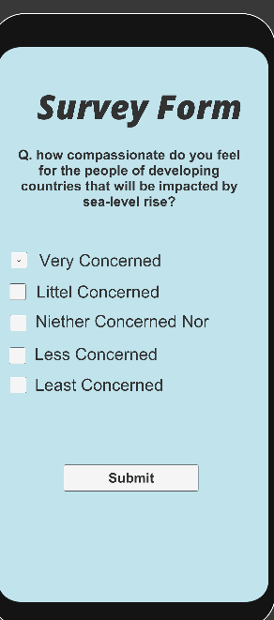

*Fig.3.1 Survey form 1 Fig.3.2 Survey form 2*

Fig 3.1 consists of a question page where we also see a submit button which is coded with the load scene function on click the unity opens new scene which was created by the developer example Fig 3.2.

3.2 Screen capture

As the application is a visual product adding a screen capture function also is widely used in the project. The function captures real-time image scenery currently visualized through one's phone.

Icon: 

**Code:**

using System.Collections;

using System.Collections.Generic;

//using System.Numerics;

using UnityEngine;

public class TakeScreenshot : MonoBehaviour

{

[SerializeField]

GameObject blink;

public void TakeAShot()

{

StartCoroutine("CaptureIt");

}

IEnumerator CaptureIt()

{

string timeStamp = System.DateTime.Now.ToString("dd-MM-yyyy-HH-mm-ss");

string fileName = "Screenshot" + timeStamp + ".png";

string pathToSave = fileName;

ScreenCapture.CaptureScreenshot(pathToSave);

yield return new WaitForEndOfFrame();

Instantiate(blink, new Vector2(0f, 0f), Quaternion.identity);

}

}

The above function code is majorly used in all kinds of scenes if the AR camera is being used in the scene.

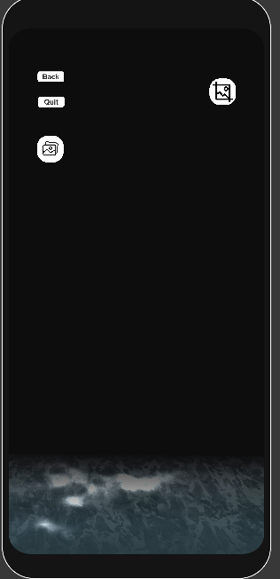

Fig 3.2.1 AR visualization

**3.3 Gallery**

The screen capture is the primary method and the second method we call upon is the gallery to see the resulting form after the screenshot is taken.

Icon : 

Code:

using System.Collections;

using System.Collections.Generic;

using UnityEngine;

using UnityEngine.UI;

using System.IO;

//using System.Numerics;

public class ScreenshotPreview : MonoBehaviour

{

[SerializeField]

GameObject canvas;

string[] files = null;

int whichScreenShotIsShown = 0;

// Use this for initialization

void Start()

{

files = Directory.GetFiles(Application.persistentDataPath + "/", "*.png");

if (files.Length > 0)

{

GetPictureAndShowIt();

}

}

void GetPictureAndShowIt()

{

string pathToFile = files[whichScreenShotIsShown];

Texture2D texture = GetScreenshotImage(pathToFile);

Sprite sp = Sprite.Create(texture, new Rect(0, 0, texture.width, texture.height),

new Vector2(0.5f, 0.5f));

canvas.GetComponent<Image>().sprite = sp;

}

Texture2D GetScreenshotImage(string filePath)

{

Texture2D texture = null;

byte[] fileBytes;

if (File.Exists(filePath))

{

fileBytes = File.ReadAllBytes(filePath);

texture = new Texture2D(2, 2, TextureFormat.RGB24, false);

texture.LoadImage(fileBytes);

}

return texture;

}

public void NextPicture() // (go to next image in gallery)

{

if (files.Length > 0)

{

whichScreenShotIsShown += 1;

if (whichScreenShotIsShown > files.Length - 1)

whichScreenShotIsShown = 0;

GetPictureAndShowIt();

}

}

public void PreviousPicture() // (go to the prev image in gallery )

{

if (files.Length > 0)

{

whichScreenShotIsShown -= 1;

if (whichScreenShotIsShown < 0)

whichScreenShotIsShown = files.Length - 1;

GetPictureAndShowIt();

}

}

}

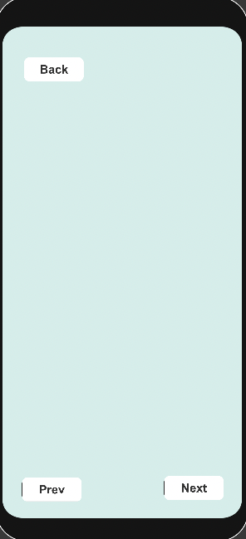

*Fig 3.3. Gallery navigation*

**3.4 Quit**

The functions end the user flow and makes tye application close when used

Code :

using System.Collections;

using System.Collections.Generic;

using UnityEngine;

public class scenequit : MonoBehaviour

{

public void QuitGame()

{

Application.Quit();

Debug.Log("Quit!");

}

}

This exists the user from the current loop running. Making it possible to close the application.

**3.5 Hashtag**

The hashtag is generated at every stimulation page to create awareness among the users to share their experiences socially. #ClimateByFocl the hashtag represents the climate change aspect presented by our application. While sharing the users would also attach the hashtag which would enable us to accumulate data on applications' social impact.

**3.6 Video Learning**

The application features a video learning page where the video perches about the climate change impact which helps users understand and feel the change in the environment daily. Topics covered in the video are: global warming and carbon emissions

**4. Figma and Unity Bundle**

Figma is a design tool that lets you create designs for mobile and web interfaces, or any other kind of design you can think of. Figma is a collaboration tool for teams and individuals to create and share high-quality work.



*Fig.4.1 Figma logo*

Creating Ui in Unity the result would be very weak. Unity would give the UI/UX a structure but the design and attraction towards the interface have to be done by Figma. The Application design for every component is taken from a Figma and then as an asset stored in unity for easy access.

The list of components:

1. Buttons
2. Icons
3. Background images
4. Borders frames

Majorly these are the things that are used throughout the project in multiple cases.

4.1 Figma

4.1.1 Buttons and Icons

The basic button with a tint feature to highlight features when clicked.

  

 

*Fig4.1 Frequent buttons*

Different button structures that have been used in multiple instances. We create them in Figma and then export them into jpg.

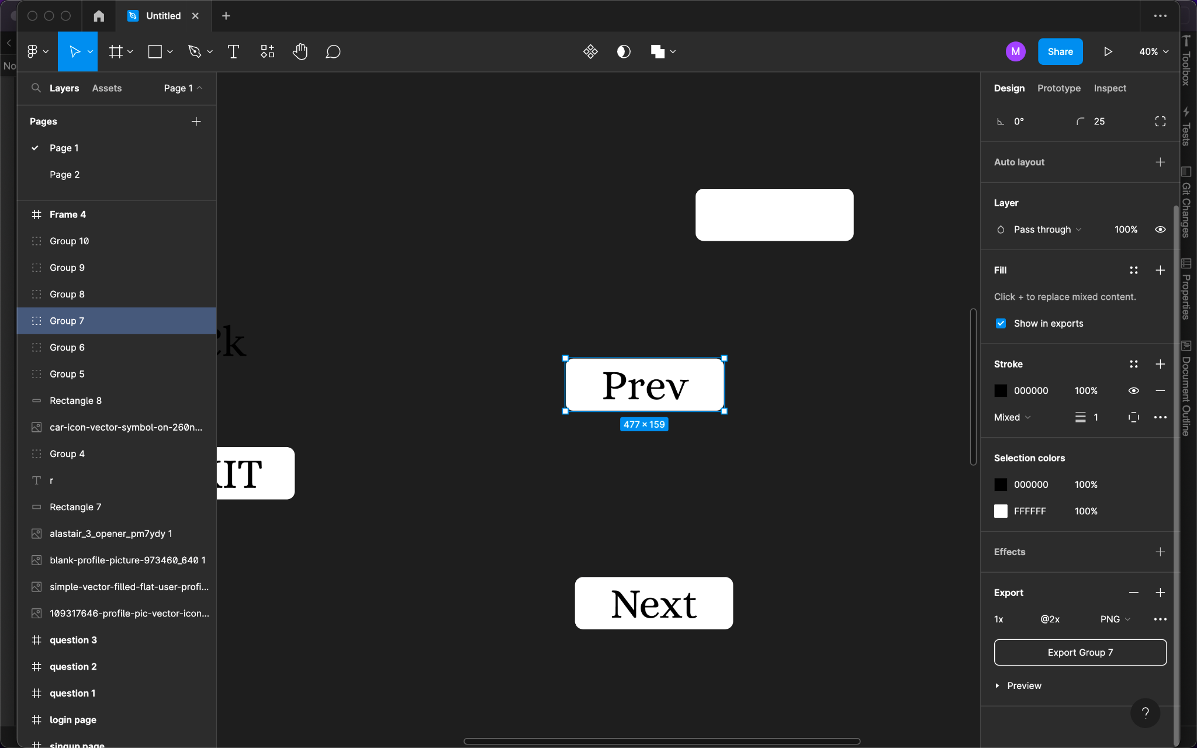

*Fig4.1.1 Conversion and designing*

The image then would have to be added to assets in the unity project. Two options: one can drag the image or just go to asset and import the asset file.

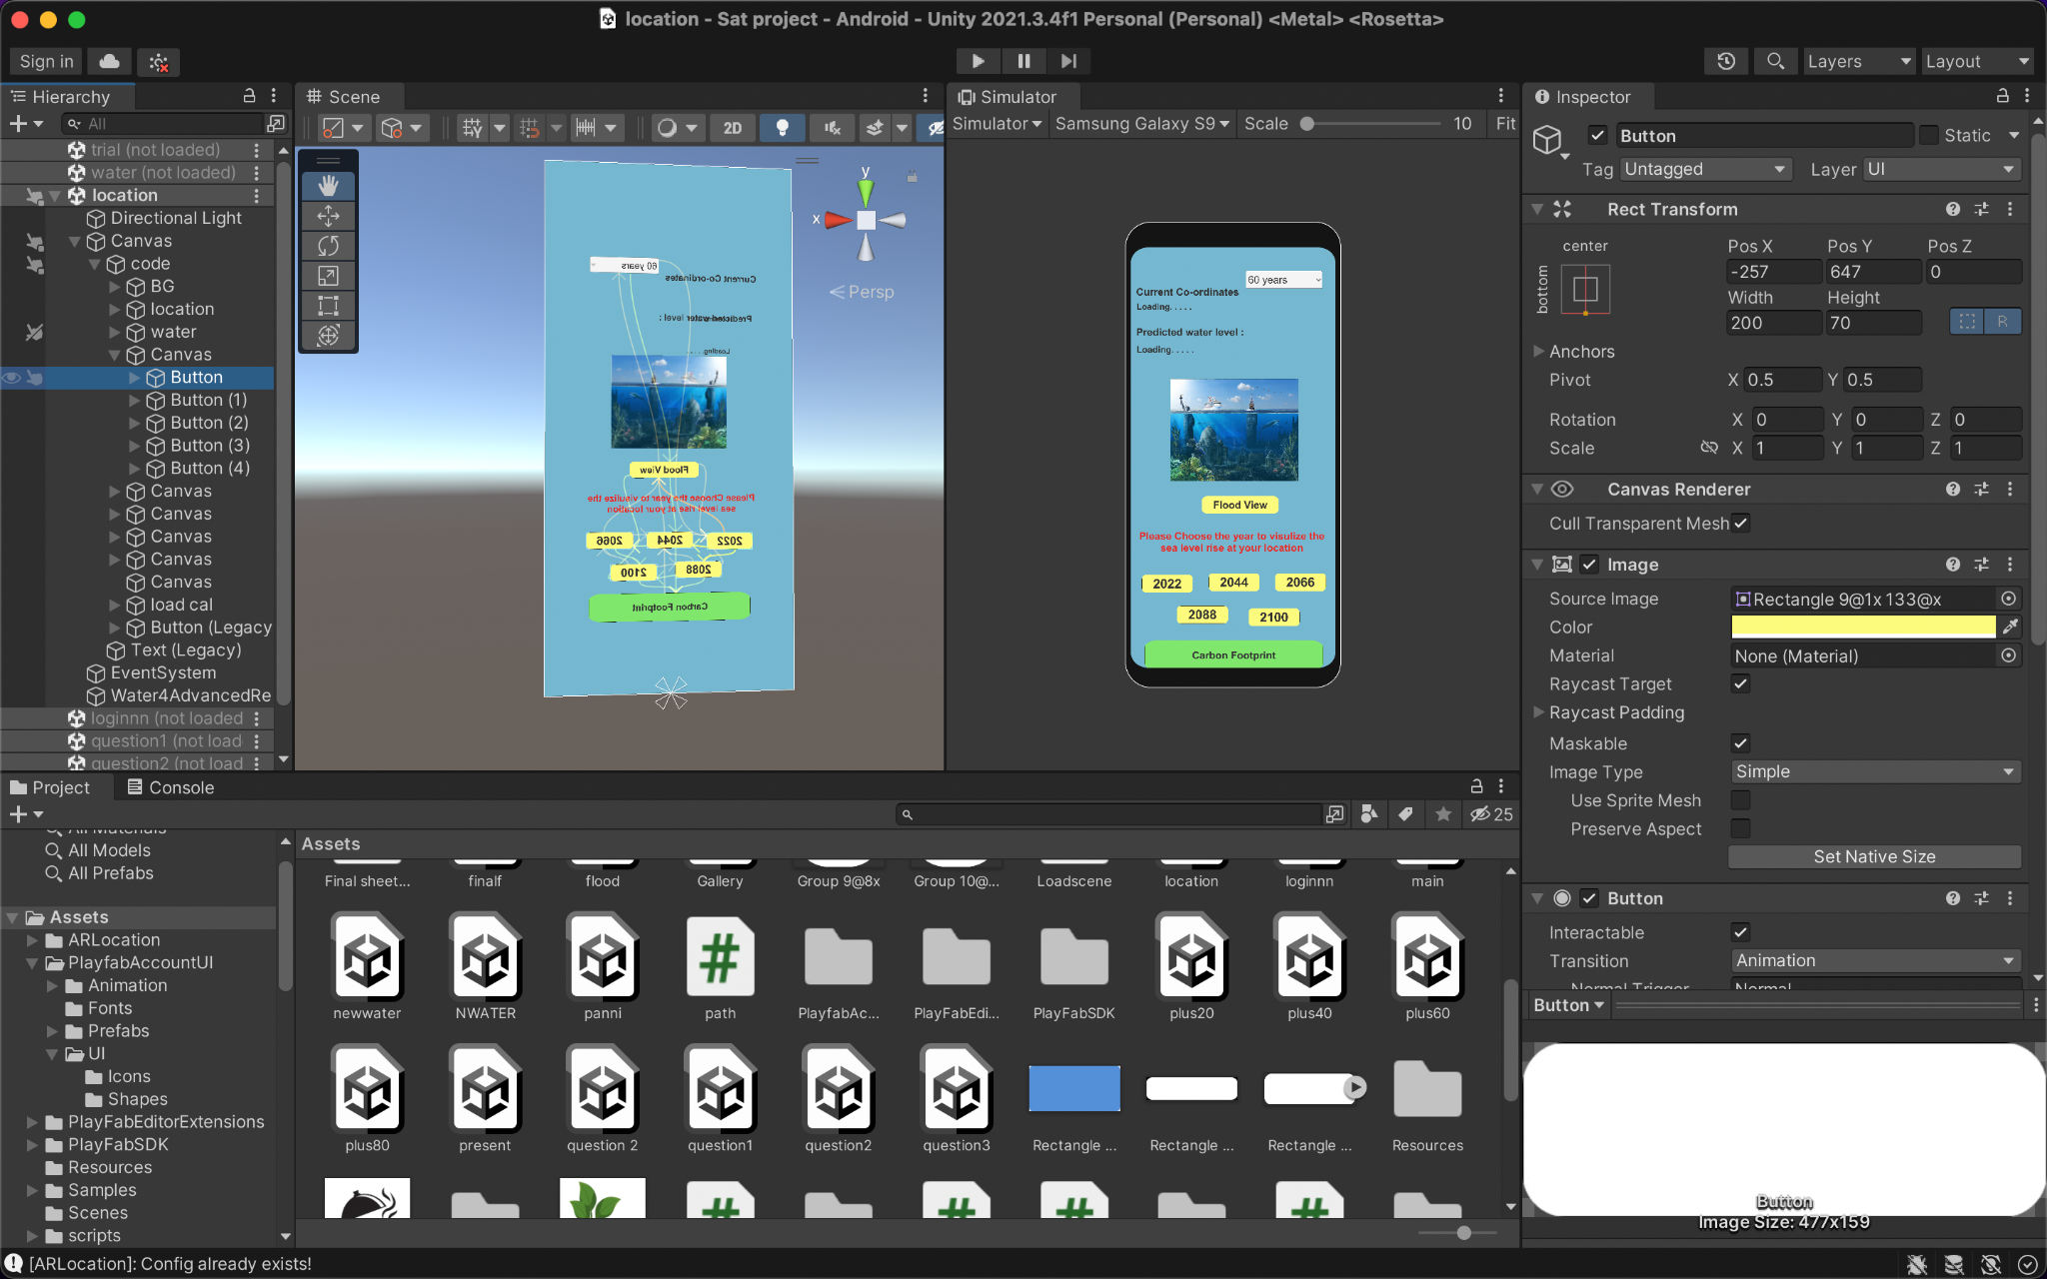

*Fig4.3 Main location and water stimulation page*

1. The asset is dragged and then placed into the source image under the button selection. This would change the button properties to Figma properties
2. Create an event system for each button if not the buttons won't behave it will become just a 2D picture in UI.

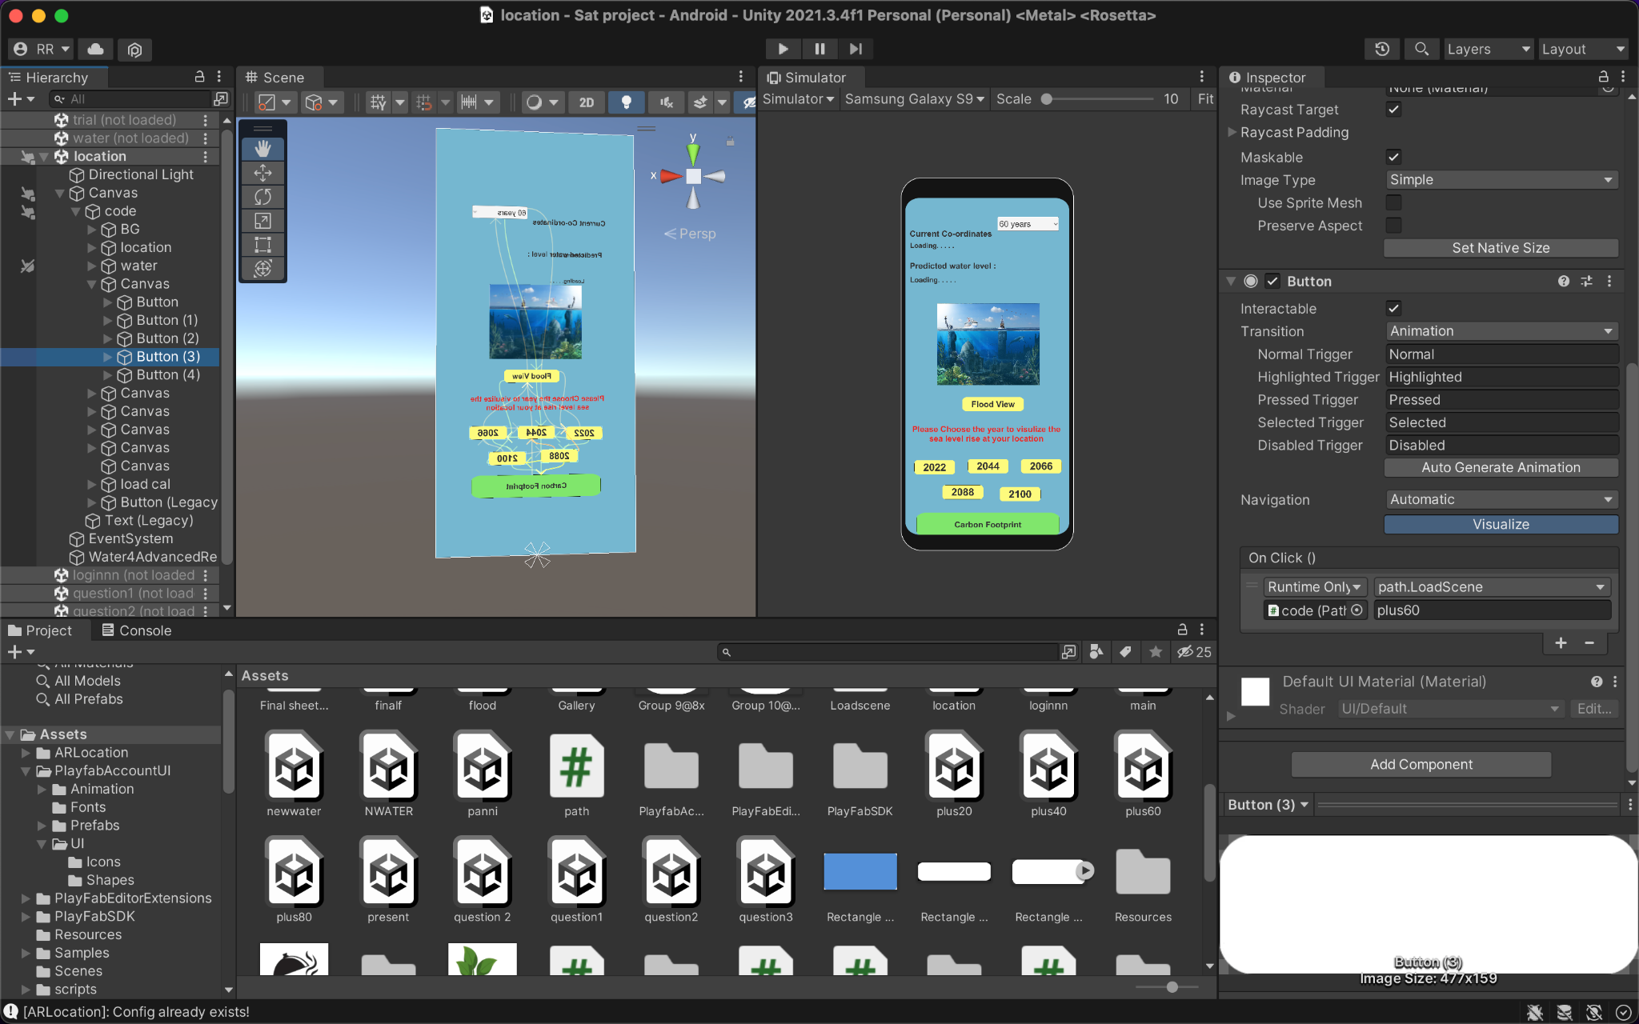

*Fig4.4 Button for 2D view*

The On click auction in inspector is set to load scene function as method above in recurring function.

**4.2 Background image**

The background features a raw image in solid dilute colors the pallet for that color combination is also present in the Figma pallet appearance. Anyone doing the UI/UX of the application must not change the pallet configuration, if so the uniformity in the application will disappear.



*Fig4.6 Color pallet*

1. The background image is added by creating a canvas first in the 2D or 3D spectrum of Unity.

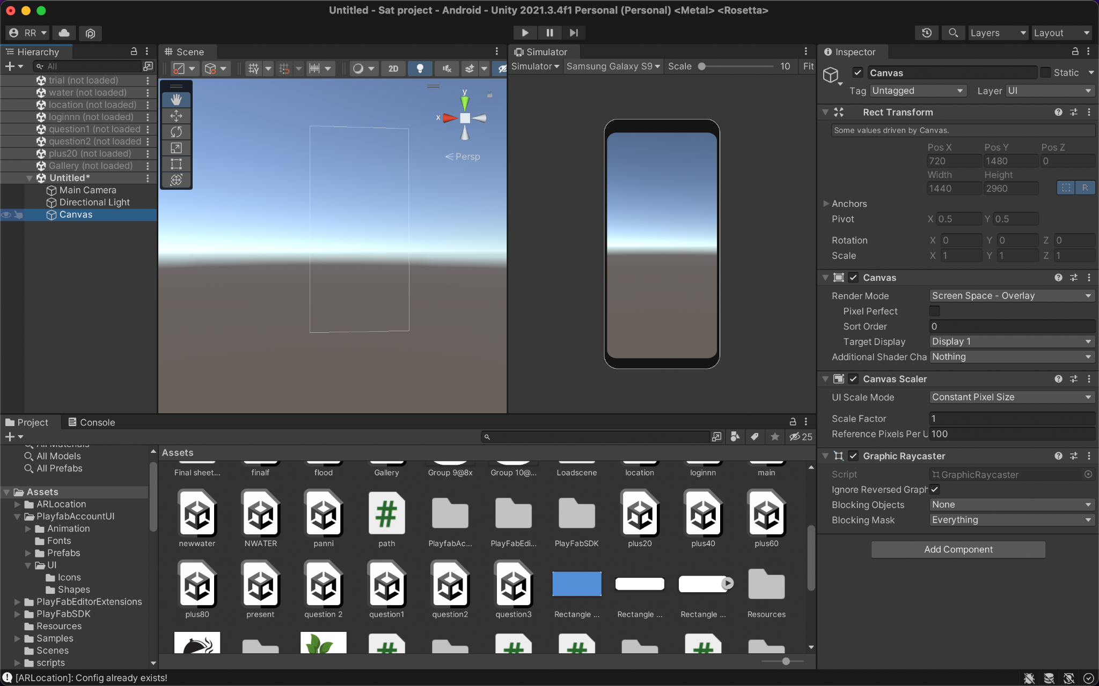

*Fig4.7 Creating a canvas*

1. Then we add image from the drop down UI options present in the canvas.

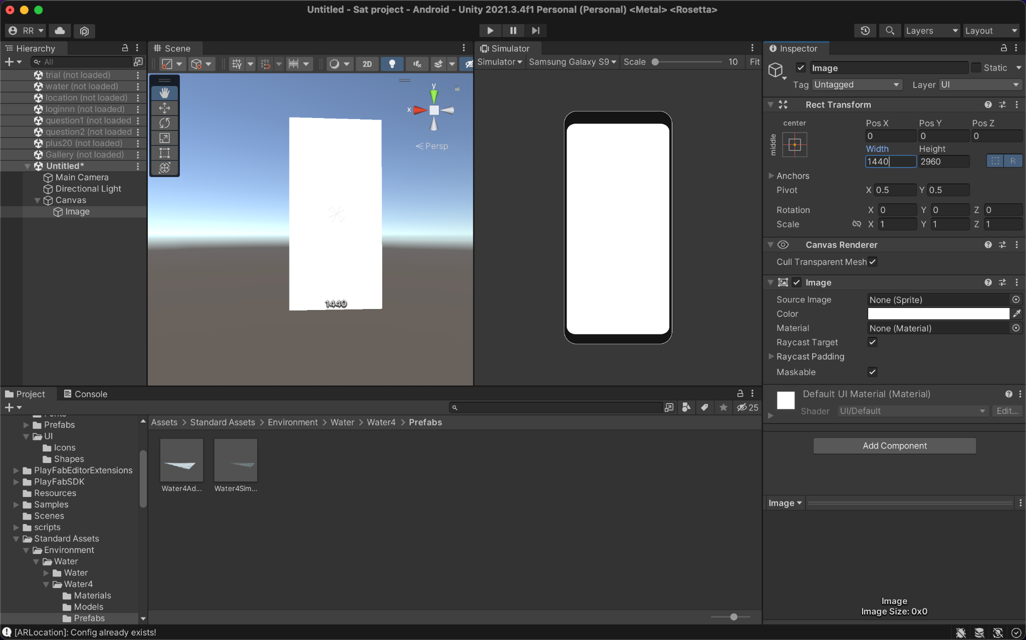

*Fig4.8 Aspect ratio for panel*

1. Then as we see the color is white for the background we change it to our preferred color combination. Mine would be dull blue from the platelet above.

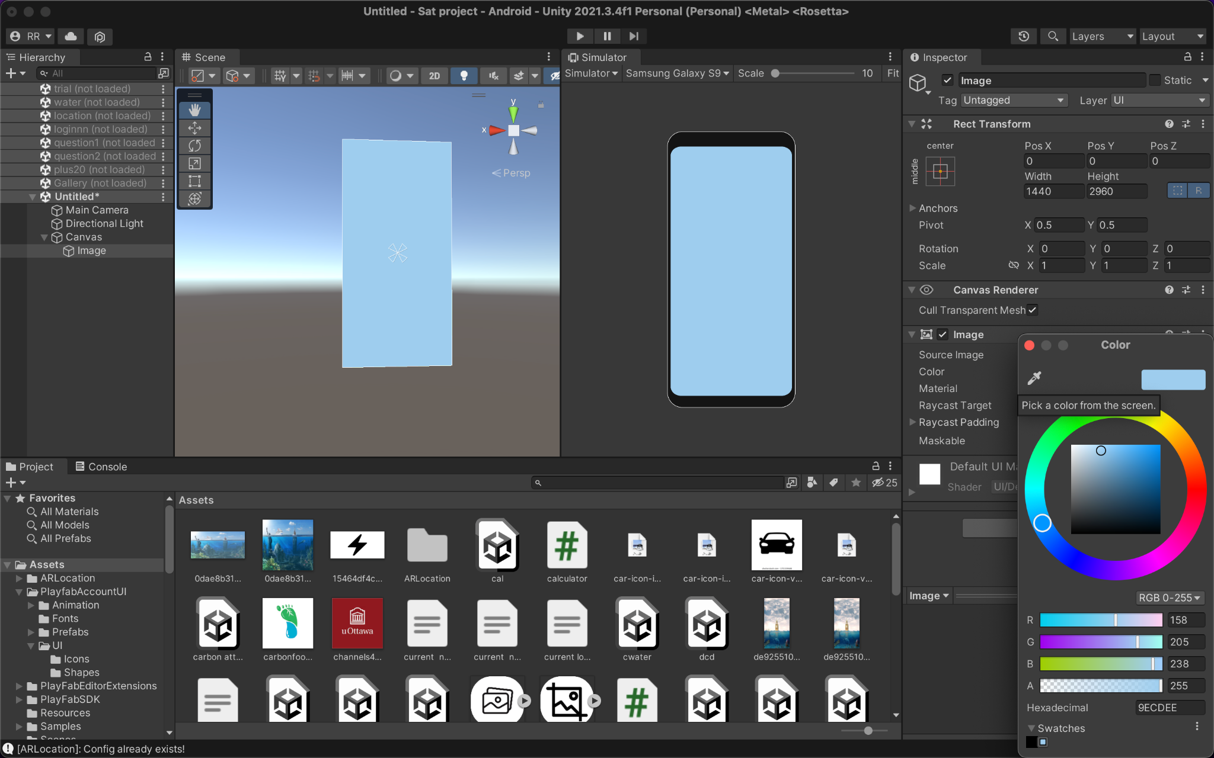

*Fig.4.9. Color pallet choice*

**4.3. Unity Design**

The segment consists of creating an account and login page, survey forms, and a carbon emission calculation page. The three main scenes in our unity assets have been created purely by using unity. The structural components for each are very similar.

**4.3.1 Login and create account**



*Fig4.3.1 Options page*

The first page consists of an options page where users choose their option. First time users will have to choose to create an account. A scene load script is added to both buttons.

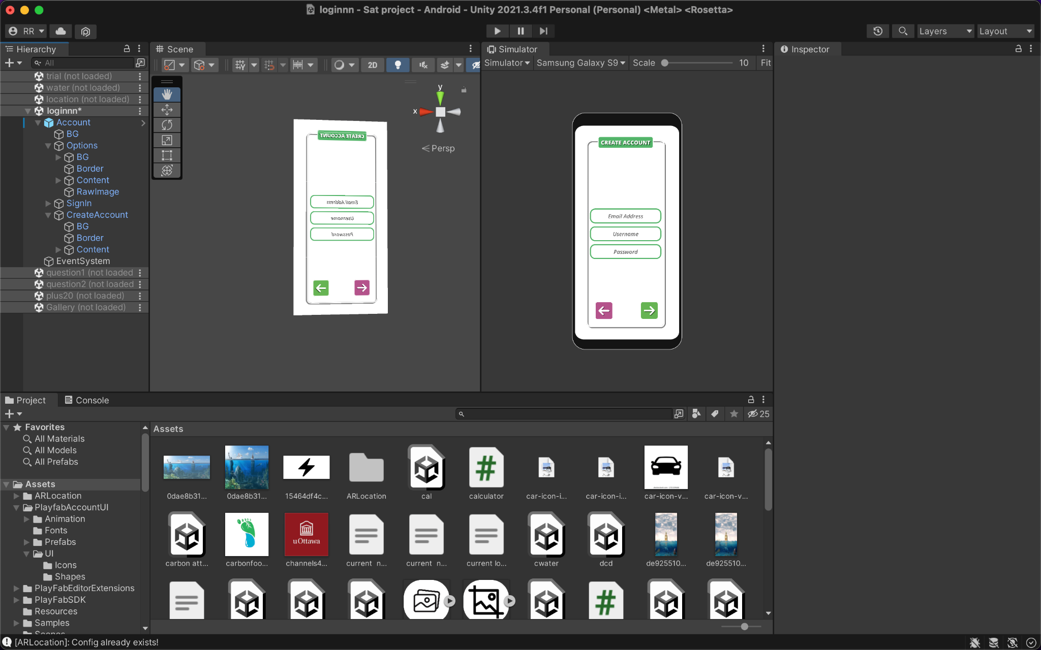

*Fig4.3.2 Create account page*

The next is to add a login page where user can login after registering in the create account tab. The page consists of only input field and a back and login button.

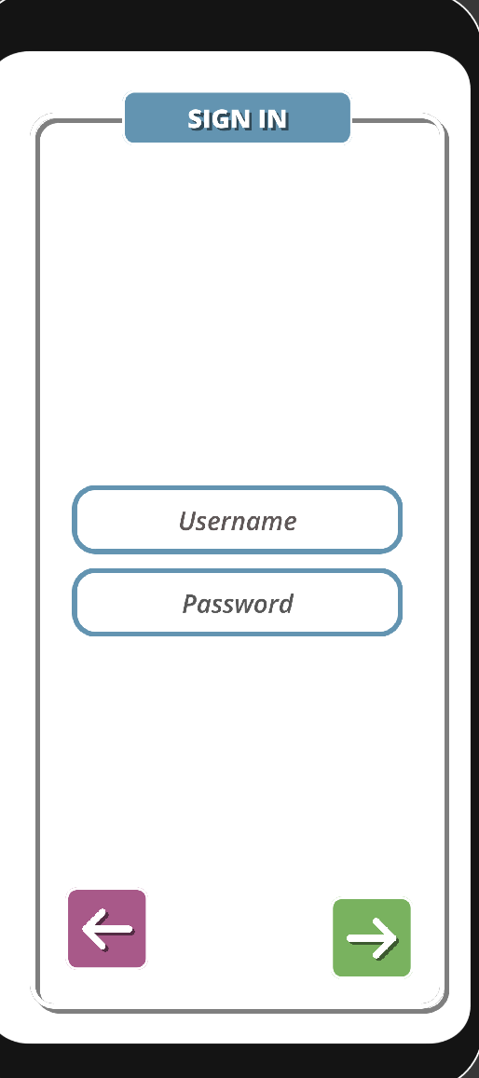

*Fig.4.3.2 Singing page*

This is all possible due to the fact the application is connected to a cloud server called Playfab which basically stores game data. We install the jdk and asset playfab to unity to get started with the server options.



*Fig4.3.4 playfab and unity integration*

**4.5 playfab and unity integration**

1. Install the Asset Package for PlayFab Unity Editor Extensions. After that, configure your Unity Project and install the PlayFab Unity 3D SDK using Editor Extension.
2. To access the Import Unity Package in the Unity Editor, go to the location where you downloaded the package and double-click on PlayFabEditorExtensions.UnityPackage file[1].

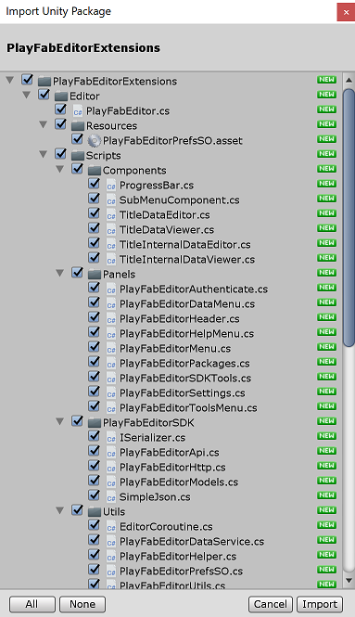

*Fig4.5 Package framework [1]*

1. When the import has been completed, the PlayFab Unity Editor Extensions panel should open automatically. If you've already created a PlayFab[1].
2. developer account, select the Log In link to log in with your PlayFab username and password[1].

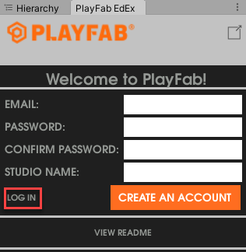

*Fig4.6 Login info playfab page [1]*

1. After logging in, the extension displays the SDK installation dialog.

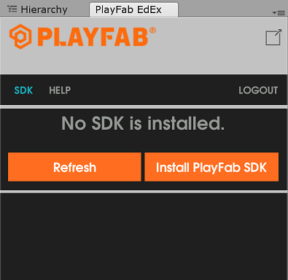

*Fig.4.7 Install SDK [1]*

1. Select Install PlayFab SDK to automatically import the SDK into your project or upgrade the version that is currently installed[1].
2. Select SET MY TITLE in the Editor Extensions.

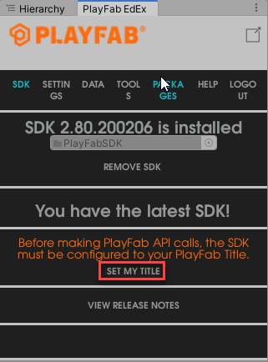

*Fig4.8. Playfab setting complete [1]*

1. Select the Studio entry to open the studio drop-down menu. Select the studio that contains the Title to which you would like to connect[1].
2. Select the Title ID entry to open a drop-down menu of Titles associated with the selected studio[1].

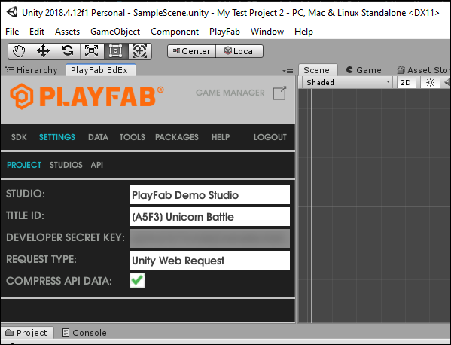

*Fig4.9 Account Summary [1]*

Create account code:

using System.Collections;

using System.Collections.Generic;

using UnityEngine;

using UnityEngine.UI;

public class UICreateAccount : MonoBehaviour

{

[SerializeField] Text errorText;

[SerializeField] Canvas canvas;

string username, password, emailAddress;

void OnEnable()

{

UserAccountManager.OnCreateAccountFailed.AddListener(OnCreateAccountFailed);

UserAccountManager.OnSignInSuccess.AddListener(OnSignInSuccess);

}

void OnDisable()

{

UserAccountManager.OnCreateAccountFailed.RemoveListener(OnCreateAccountFailed);

UserAccountManager.OnSignInSuccess.RemoveListener(OnSignInSuccess);

}

void OnCreateAccountFailed (string error)

{

errorText.gameObject.SetActive(true);

errorText.text = error;

}

void OnSignInSuccess()

{

canvas.enabled = false;

}

public void UpadteUsername(string _username)

{

username = _username;

}

public void UpadtePassword(string _password)

{

password = _password;

}

public void UpadteEmailAdress(string _emailAddress)

{

emailAddress = _emailAddress;

}

public void CreateAccount()

{

UserAccountManager.Instance.CreateAccount(username, emailAddress, password);

}

}

**Account manager code**

using System.Collections;

using System.Collections.Generic;

using PlayFab;

using PlayFab.ClientModels;

using UnityEngine;

using UnityEngine.Events;

public class UserAccountManager : MonoBehaviour

{

public static UserAccountManager Instance;

public static UnityEvent OnSignInSuccess = new UnityEvent();

public static UnityEvent<string> OnSignInFailed = new UnityEvent<string>();

public static UnityEvent<string> OnCreateAccountFailed = new UnityEvent<string>();

void Awake()

{

Instance = this;

}

public void CreateAccount (string username, string emailAddress, string password)

{

{

PlayFabClientAPI.RegisterPlayFabUser

(

new RegisterPlayFabUserRequest()

{

Email = emailAddress,

Password = password,

Username = username,

RequireBothUsernameAndEmail = true

},

response =>

{

Debug.Log($"Succcesful Accopiunt Creation: {username}, {emailAddress}");

SignIn (username, password);

},

error =>

{

Debug.Log($"UnSucccesful Accopiunt Creation: {username}, {emailAddress} \n {error.ErrorMessage}");

OnCreateAccountFailed.Invoke(error.ErrorMessage);

}

);

}

}

public void SignIn (string username, string password)

{

PlayFabClientAPI.LoginWithPlayFab(new LoginWithPlayFabRequest()

{

Username = username,

Password = password

},

response =>

{

Debug.Log($"Successful Account Login:{username}");

OnSignInSuccess.Invoke();

},

error =>

{

Debug.Log($"UNSuccessful Account Login:{username}\n {error.ErrorMessage}");

OnSignInFailed.Invoke(error.ErrorMessage);

}

);

}

}

SignUp Page

using System.Collections;

using System.Collections.Generic;

using UnityEngine;

using UnityEngine.UI;

public class UISIngIN : MonoBehaviour

{

[SerializeField] Text errorText;

[SerializeField] Canvas canvas;

string username, password;

void OnEnable()

{

UserAccountManager.OnSignInFailed.AddListener(OnSignInFailed);

UserAccountManager.OnSignInSuccess.AddListener(OnSignInSuccess);

}

void OnDisable()

{

UserAccountManager.OnSignInFailed.RemoveListener(OnSignInFailed);

UserAccountManager.OnSignInSuccess.RemoveListener(OnSignInSuccess);

}

void OnSignInFailed(string error)

{

errorText.gameObject.SetActive(true);

errorText.text = error;

}

void OnSignInSuccess()

{

canvas.enabled = false;

}

public void UpadteUsername(string _username)

{

username = _username;

}

public void UpadtePassword(string _password)

{

password = _password;

}

public void SignIn()

{

UserAccountManager.Instance.SignIn(username, password);

}

}

**PlayFab database**

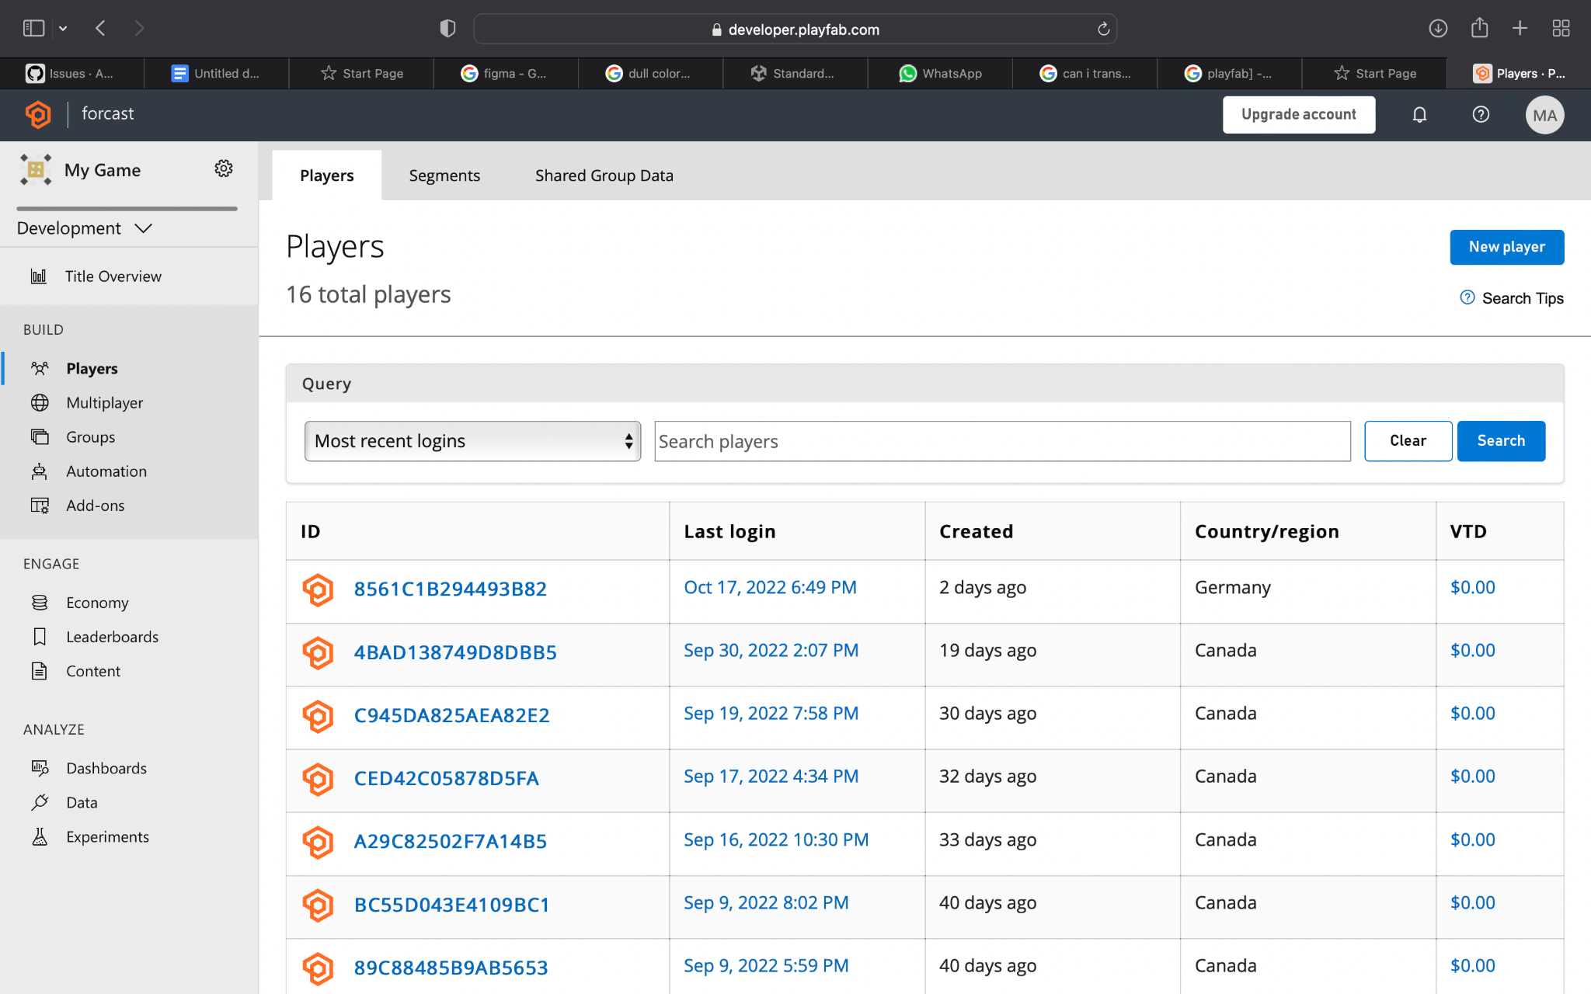

*Fig.4.10 Database in Playfab [1]*

4.6 Survey questionnaire

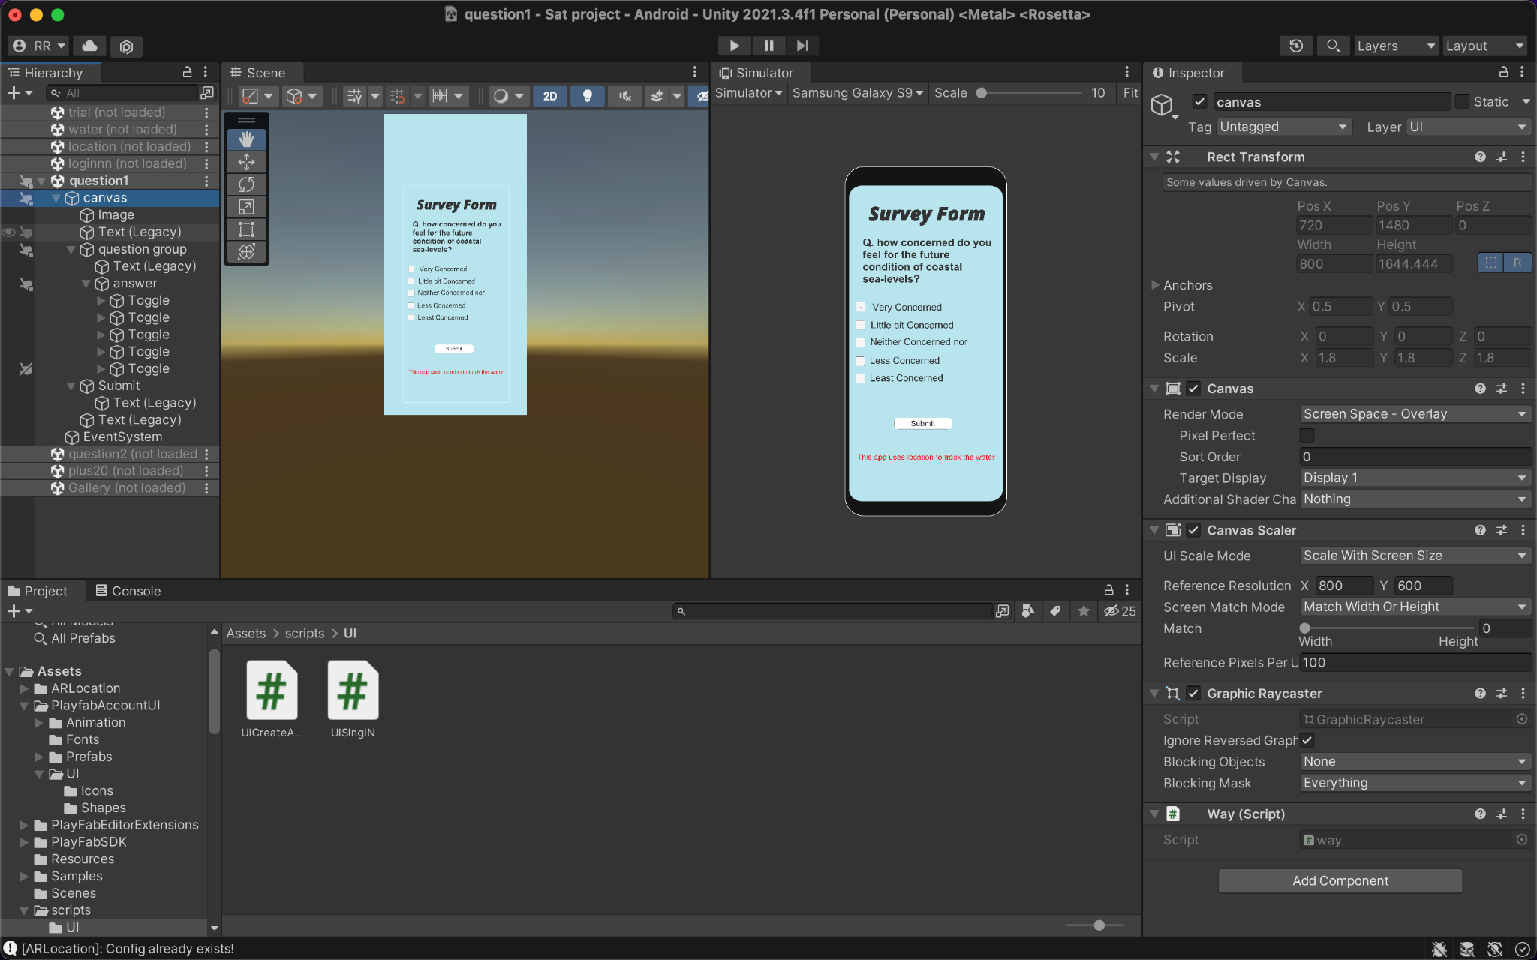

*Fig.4.11. Survey forms*

The Survey questionnaire consists of three multiple questions that have to be added at the start of the application after the lo-fi and another set after the person exits the application to make a feedback survey of empathy after the visual confrontation of sea level rise in the surrounding area.

**5. Conclusion**

The documents contain backend and UI/UX development components and steps that we have gone through while creating this application. Codes in the document are well commented on and also self-explanatory. For account purposes, we have established a link to Playfab that is also a sequential process to follow from section 4.5 in the document.

**References**

1. DanBehrendt. (n.d.). *Installing the Playfab SDK for Unity - Playfab*. PlayFab | Microsoft Learn. Retrieved March 10, 2023, from <https://learn.microsoft.com/en-us/gaming/playfab/sdks/unity3d/installing-unity3d-sdk>
2. GitHub. (n.d.). Retrieved March 10, 2023, from <https://raw.githubusercontent.com/djp3/TerraTower/v0.0.1_candidate/UnityTerraTowerClient/UnityTerraTowerClient/Assets/MyLocation.cs>
3. Technologies, U. (n.d.). *LocationService.start*. Unity. Retrieved March 10, 2023, from <https://docs.unity3d.com/ScriptReference/LocationService.Start.html>